Coronavirus and Community Association Insurance
Managing Expectations during the Pandemic
(Copyright © 2020 Joel W. Meskin)

By Joel W. Meskin, Esq., CIRMS, CCAL Fellow, MLIS, EBP

THIS ARTICLE IS NOT A LEGAL OPINION, IS NOT THE POSITION OF ANY SPECIFIC INSURER
OR THE MCGOWAN COMPANIES. THESE ARE THE BEST THOUGHTS OF THE AUTHOR.

INTRODUCTION

The Coronavirus Pandemic has found most of us with our arms up in the air. These are definitely uncharted waters.

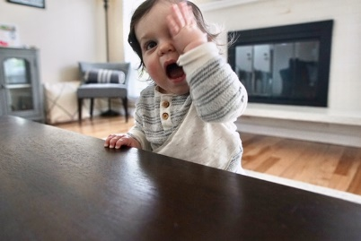
What am I going to do?

My question, as someone who has been spending a great deal of time answering questions on the Coronavirus and insurance coverage is, “Did any prior pandemic, epidemic or outbreak of a communicable disease lead to the myriad of insurance issues we are now being asked to respond to with clear and immediate responses?” Perhaps our standard answer should be “maybe” or “it depends on many variables” before an intelligible response can be provided.

This conundrum provides numerous opportunities for creative coverage attorneys representing insureds to boldly assert and plausibly argue that they can find coverage where no such coverage was intended to exist. To trigger coverage under the insured(s) Association Property Policy, it requires the existence of the Coronavirus in a common area constituting “property damage.” To satisfy the existence of property damage, most property policies require that there is a "Covered Cause of Loss" (i.e. Is the coronavirus a covered cause of loss?) that results in direct physical loss of or damage to the insured(s) covered property? I presume, but do not assume, that these requirements will not be met to trigger coverage for direct physical damage in the majority of jurisdictions. I also presume, but do not assume, that contingent damages arising or resulting from the alleged property damage will not be covered. These potential coverages include business interruption loss, loss of business income or loss of use.

The anticipated arguments, protracted litigation, attorney fees and costs, as well as the fees and costs of countless multidisciplinary experts will depend on specific policy wording, state laws, court interpretation, judges and creative attorneys. All these factors will ultimately determine coverage or no coverage. These coverage issues and related litigation will undoubtedly go on for years, or until the insureds can no longer afford the fight. If you would like to get a taste of what we can expect, just Google “Insurance Coverage Issues arising out of the World Trade Center Occurrence/Occurrences”. On the other hand, insurers may choose to resolve such claims on a cost of business basis. However, this is less likely due to the nature and extent of the potential claims.

I do not believe that insurers ever intended for coverage to exist under these circumstances. There are potential cases where express language, endorsements or definitions providing coverage exist. I also confidently contend that actuaries did not consider these exposures in developing rating and other modeling they use to best anticipate acceptable loss ratios and underwriting criteria, which are necessary to properly price coverage for the intended exposure. Again, this is different where there is specifically crafted or included provisions creating coverage.

COMMUNITY ASSOCIATION INSURANCE FOR CORONAVIRUS

The following chart sets forth the basic community association insurance puzzle. It is anticipated that insured(s) may seek coverage under the four highlighted policies below, General Liability, Directors and Officers Liability Coverage, Workers Compensation Coverage and Property Coverage.

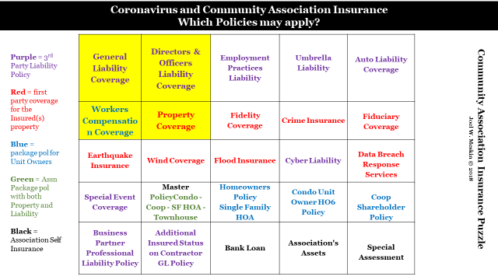

The focus of the issues set forth below involves the “common elements, property and amenities” of a not-for-profit community association such as a Condo, Coop or HOA. In addition, the focus here is on the alleged consequences from the coronavirus existing in/on a common element. These may have issues that differ from an analysis of a business where direct financial loss will result from the closure of a business due to direct physical loss to the insured’s property.

In order to analyze the existence of coverage under the various community association programs, it is helpful to understand how to look at and review an insurance policy. Notwithstanding the bad rap that insurance policies have for being filled with small print and legalese, there is a method to the madness. Carriers need to protect the intent they have behind an insurance product. Accordingly, if they do not cross every “t” and dot every “i”, they will be challenged on virtually every claim because without being this careful, the policy will be attacked as having language that is vague and ambiguous resulting in having the language being construed in favor of the insured(s).

For all intent and purpose, all property and casualty policies are built the same way. Specifically, they are structured as follows:

- Insuring Agreement – Gives you the world
- Definitions – Defines the World
- Exclusions – Takes away a part of the world
  - Covered under another policy
  - Would make the policy unaffordable if not excluded
  - Against Public Policy
- Conditions – What insured must do to trigger coverage
- Endorsements and Amendments – change the basic form.
  - Issued with policy
  - Including State Amendatory endorsements
  - Added later

As the issues below are reviewed, the structure set forth above will help understand why coverage is applicable to the potential Coronavirus alleged claim for injury or damage.

Issue No. 1: Most property insurance policies require that the insured(s) property suffer direct physical damage to insured property resulting from a covered peril. Does the existence, or possible existence of Coronavirus constitute direct physical loss or damage to insured property?

Response No. 1: Probably not.

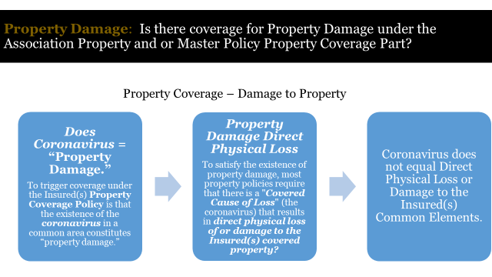

Insured(s) will try and assert that the Coronavirus introduced into the common elements constitutes direct physical loss or damage. Policy interpretation is subject to state law. Courts in some states have opined that contamination and other incidents that render property uninhabitable or otherwise unfit for its intended use constitutes a "physical loss." However, I believe that this is the minority opinion. Moreover, this argument would not be to the Coronavirus.

The Coronavirus issue in community associations is not really the existence of contaminated property as a result of the virus. One study concluded as follows:

“The researchers behind the new study tested the virus' life span in a 71-degree-Fahrenheit room at 65% relative humidity. After three hours, the virus had disappeared from printing and tissue paper. It took two days for it to leave wood and cloth fabric. After four days, it was no longer detectable on glass or paper money. It lasted the longest, seven days, on stainless steel and plastic.”

The Coronavirus issue in community associations arises out of the closing of non-essential common elements to prevent social gathering and the spread of the virus from person to person. Associations that do not follow governmental orders or the recommendation of health care providers, should be concerned with potential liability. Not only liability, but liability that is not covered by insurance.

The Coronavirus, as is discussed each day all day in the news, has an extremely short life. By the time that the property can be tested for any contamination by Coronavirus, or the governmental orders are lifted, the existence of the Coronavirus would be moot. The Coronavirus would no longer exist.

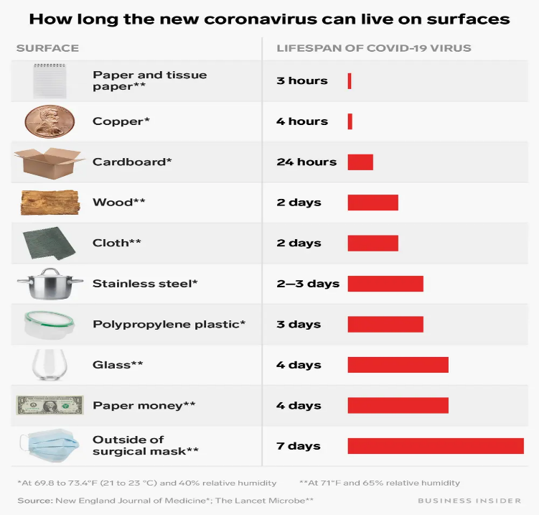

The physical nature and life of the Coronavirus is different than that of asbestos and mold where there are much stronger arguments that they constitute contamination of actual property and will not go away without remedial measures. Coronavirus will self-eliminate.

Issue No. 2: Is there coverage for testing and or remediating costs?

Response No. 2: Probably Not.

There is no coverage for testing or remediation costs, again, if there is no direct physical damage or loss. The discussion to this response is the same as Response No. 1.

Issue No. 3: In the unlikely event that the coronavirus is considered “property damage” will there be any other impediment to coverage?

Response No. 3:

- Yes. Even if the property damage is established, there are numerous exclusions that would apply. These exclusions further support that insurers had no intent to provide coverage.
- No. Coverage may exist where a policy might have a specific endorsement. This is not likely for community associations, however, because of extremely prohibitive costs. This is more likely in an industry such as restaurants and the hospitality industry where the significant price can be included in the cost of doing business. These supplemental coverages in the normal course will not include the direct physical loss of damage requirement. Accordingly, the mental gymnastics of whether there is property damage or not is avoided.
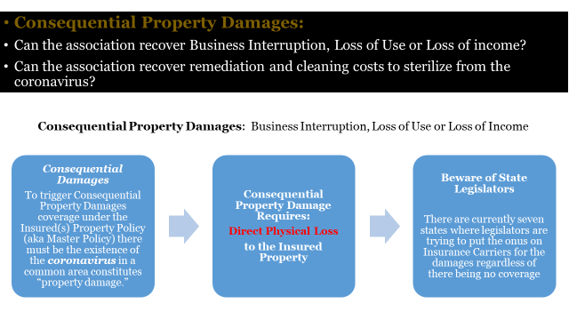

Issue No. 4: Is there coverage for consequential damages, such as Business Interruption, Loss of Income or Loss of Use?

Response No. 4: No.

To trigger these coverages for consequential damages, the damage must again result from direct physical damage or loss to the insured(s) property. Accordingly, the same discussion in Response No. 1 above will apply here.

Keep in mind that business interruption insurance is intended to protect businesses against income losses sustained as a result of disruptions to their operations. Contingent business interruption coverage similarly provides insurance for financial losses resulting from disruptions to a business's customers or suppliers, usually requiring that the underlying cause of damage to the customer or supplier be of a type covered with respect to the business's own property.

In the community association context, the interruption of operations may be argued to be the unit owner members’ inability to pay fees and assessments. This is not the result of Coronavirus in the community association, but the result of the impact on their business or employment. This is too attenuated from the community association. With respect to the association’s inability to pay business partners, such as landscapers, pool services or the like, the potential issue would not be a property policy issue. The potential risk will be a claim or suit against the association for breach of contract. As a breach of contract issue, there may be a defense pursuant to a Force Majeure provision in the contract (unforeseeable circumstances that prevent someone from fulfilling a contract).

Issue No. 5 If the board opens common elements, such as pools, clubhouses and gyms, will any insurance policy defend or indemnify the board?

Response No. 5: No.

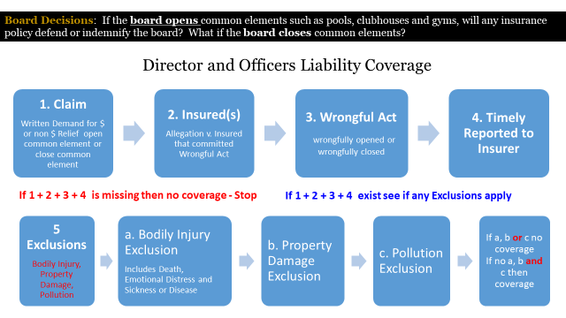

Issue No. 6: If a unit owner or guest got sick with Covid-19 alleging the association negligently maintained the common elements that could not be closed (i.e. elevators, entry doors or stairways)?

Response No. 6: Probably No.
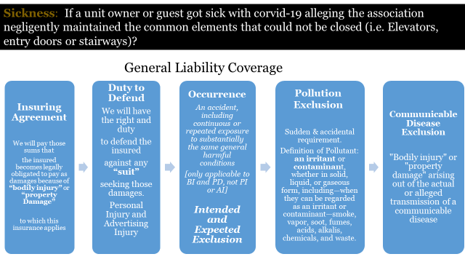

Issue No. 7: Is the Covid-19 disease covered under a workers compensation policy?

Response No.7: No.

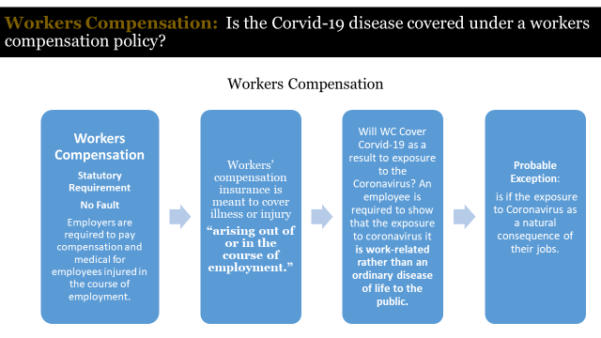

CONCLUSION:

After reviewing each policy step by step, I opine that there is not going to be coverage under any of these policies for any of the issues presented. However, that does not preclude the possibility that attorneys will not challenge the basic policy forms. Insureds will have to do a cost benefit analysis in the event there is a possibility to challenge a policy provision.

Business Insider, April 7, 2020 - https://www.businessinsider.com/coronavirus-lifespan-on-surfaces-graphic-2020-3

